LLM-based Agent for Driver Sleepiness Detection
and Mitigation in Automotive Systems
Semester / Year: SoSe 2025
Student Name: Yashraj Sawant
E-mail: yas7500@thi.de
Date of submission: 22.07.2025

Declaration of Original Work
I hereby certify that the work described in this individual report is my own and that all sources I used in the generation of the report (including AI-tools) are properly cited.
Signature: ______________________ Date: 21.07.2025

1. Summary Overview (~ 250 words / ½ page)
In this project, I was part of two sub teams which are Input Signal Processing team and Feature Extraction team.
Input Signal Processing Team
Role:- Developer
Contribution:-
- Extracted the data from the Ros Bags and then sync the data(Carla data + IR camera) according to the ROS time stamp so that feature extraction team can try their pipeline for extracting features (this was done for offline data).
- Tried to implement the ROS node in the system for online synchronization of both the data was successful in doing so.
Feature Extraction Team
Role: Algorithm Developer for extracting features from the data coming from CARLA Simulator.
Contribution:-
- During the initial days of project did research on how to get the valuable features which are essential for drowsiness detection and how can we get them.
- Created Guidelines for data capturing for the CARLA Data from the simulator.
- Then created a fake CARLA dataset as there was no valuable dataset available on the internet which could be used to test the offline feature extraction pipeline
- In late May the sample data was provided by data capture team in which I found out that the way CARLA captures the data in a very different way, so had to make changes accordingly.
- In the mid June when data was recorded, I tried to extract the features on that and was successful but there was an issue related to the change of lane and it’s detection.
- At the end of project on 8th July created the ROS node for CARLA feature extraction and implemented it in the system and subscribed it to the data sync node and was successful in extraction features online.
2. General Contributions (~ 250 words / ½ page)
Team part of | Contribution in terms of % in that team
Signal Processing Team | 50%
Feature Extraction | 25%

In both the team I collaborated on Github(https://github.com/haider-maker/Driver-Drowsiness-Detection) in which I created 2 branches (03-Carla and 04-Ros-data) one for feature extraction and one for signal processing part. In that I regularly pushed the data or code so that the other team mates can see how and what is the progress.
We had regular meetings within the grp and with other teams regarding the feature extraction and CARLA behaviour and ROS nodes. For instance, for we had meeting with Data Capture Team regrding how the data is being capture and which data should be capture, we had discussion with Signal Processing Team regarding the time sync part, we also had discussion with LLM team as how data they need we should publish which could be helpful like only the fatigue level or the feature vector also, and as we all were new to ROS node concept we also had meeting with Auto UI team as they had more experience with ROS 2 Nodes and the concept of ROS, they were also helpful in providing a detailed guideline and explaining how it works, which was helpful for us while creating the ROS nodes
In the final joint paper I wrote down the part Data Signal Processing and Feature Extraction of Vehicle from Carla Simulator, in which I have mention all the working bits regarding the online feature extraction via ROS nodes and time sync of both the data from data capture module.
3. Role-Specific Contributions (~ 700 – 800 words / 1½ page)
I was involved in two teams:-
- Input Signal Processing Team:-
In this team my specific contribution was to test the offline pipeline and act as a middle man for the data capture team and feature extraction team as I was the part of feature extraction team so it would be easy to process the data according to my team’s need and to communicate with data extraction team about the requirement. Me and any team mate(Ghulam) came up strategies like we will sync the data according to the slower sensor and delete the extra data which was recorded by the faster sensor. Our main work started when the data was recorded, but till the meantime as I had no previous experience with CARLA running successfully and ROS, I tried to implement and get my own data on my personal Laptop. To get the sense of lateral offset being calculated.
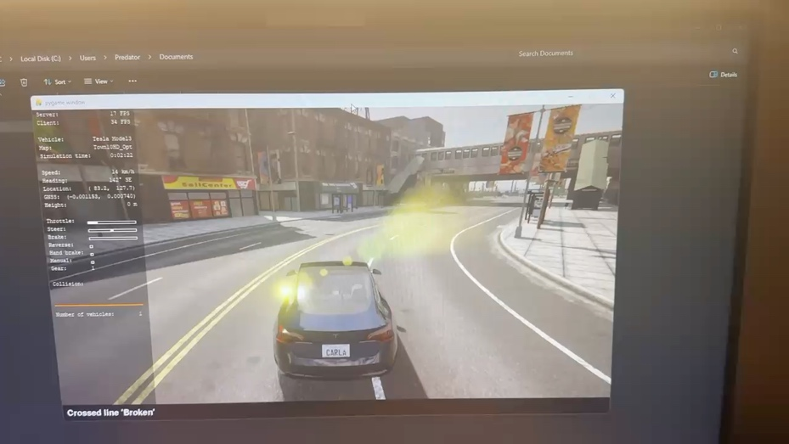

Vid1:- Overlaying the Carla waypoint(lane center) with yellow color and the vehicle position with red color.

So Ghulam created a python script to sync the data first for the offline pipeline, I then extracted the data from the ROS bags(data captured for offline pipeline) in one folder and then synced the data with the Ghulam’s script to the carla’s data which was being recorded at 10Hz but we had mentioned the requirement stated by feature extraction team was that it should be recorded at 20Hz both the data but this was not consider during the initial phase of the data recording so we recorded the CARLA’s data at 10hz and IR camera’s data was sync to it and then tried my offline feature extraction script
- Feature Extraction Team:-
In this team my part was to extract the features from the CARLA’s data, we from the initial stage were clear that we will get the lateral offset value of the vehicle with respect to each lane it is present and the steering angle which was used as a recording instrument.
I researched and read paper related to how to extract the features and from where can we get the official dummy dataset but we were not successful to find any dataset relevant, but data capture team provided us with a Kaggle link in which we can at least see how a steering values look like, it was just to visualize how the data can and might look like, then by April end I had installed the CARLA 0.14 version on my laptop so that I can run the script and see myself how the data would look like, I created my own script to capture the steering angle and the lateral offset for my understanding and also how the Carla waypoints are being captured I overlayed it with the some color to clearly visualize it as seen in vid 1.
There I noticed like for our simulator as we are using the steering angle we will always have a continuous value but since I was controlling my vehicle on my laptop with “W”, “A”, “S”, “D”, it will not be a continuous value, it will go to 0 always.
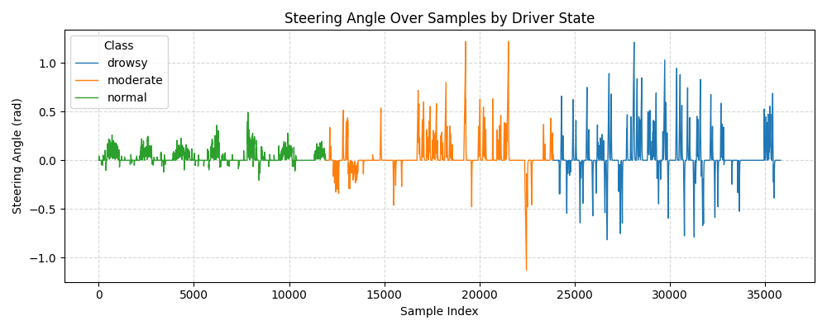
Fig No.1 :- Data capture on my local pc with “WASD” as input for controlling vehicle.
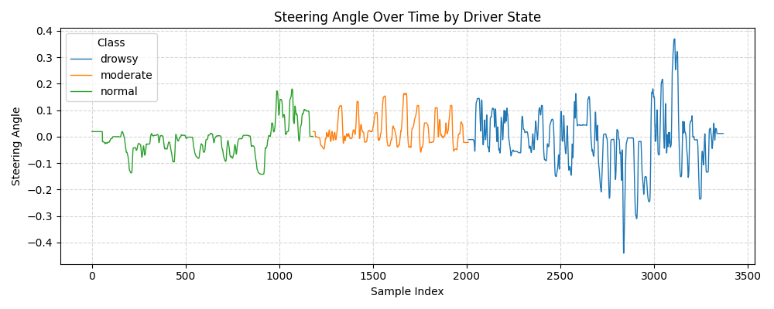
Fig No.2 :- Data capture on my simulator pc with physical steering wheel as input for controlling vehicle.
But this data(Fig no.2) was provided to me during the end of the month May, so it was then when I realized that if I created my own data of steering angle on my laptop it will be of no use in extracting features from steering angle data. But at least I understood that this might be the difference when recording the data from the physical steering angle and directly from the laptop.
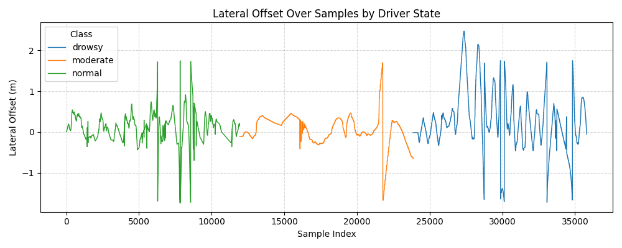
Fig No.3 :- Data capture of lateral offset on my local pc
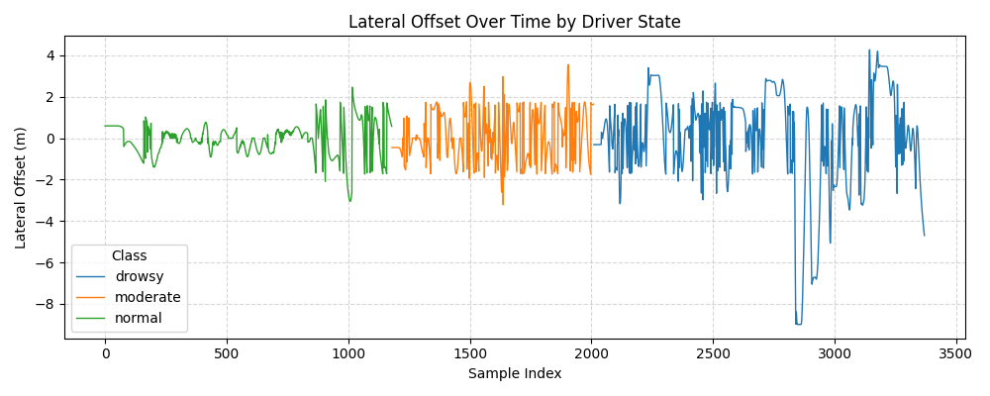
Fig No.4 :- Data capture of lateral offset on simulator
Then we proceeded with lateral offset data, in the beginning of the implementation of the project phase, we were told like we will get the lateral offset data in a range of +1.75 to – 1.75. Positive being on the right side of the lane center and Negative being the left side of the lane center. But since I was also simultaneously capturing the data for lateral offset on my pc, I did noticed that the lateral offset changes randomly when the vehicle is at the intersection(Fig no. 3) , the CARLA is not able to process the waypoint, but since I was using an old graphic card, I thought it might be a hardware issue, like in a high end graphic card the unreal engine might run smoother and it might get more FPS which will help the CARLA simulator to capture the data some correctly, but when the 1st data was provided by data capture team in that also the vehicle behaved very unknown pattern(Fig. No. 4). Technically the vehicle should not go beyond the range of +-1.75. But as seen in the (Fig. No. 4) the drowsy state driving behavior records the data being reached to -8m to +4m, which is strange. So to get the sense of why the lateral offset goes to -8m we requested the lane id also along with the lateral offset, but our requirement was not satisfied and we were not provided with the relevant data to debug this problem. The error was not considered in subsequent stages, but later it created problem in detection of the lane change. So, Theresa me and Mehdi had a meeting and came up with a solution like Theresa will record the data(lateral_offset) and also record herself and the vehicle while driving with a phone so we can interpret what is happening. So, we found out like the CARLA sticks to the original lane as long as its centerline is still "closer" to the vehicle than the centerline of any other lane, so to overcome this I decided to detect the lane change when the vehicle is 1.575m away from the center line and then only confirm if the sign is change and remains in that new lane for 5 Sec at least. So according to 20hz we will have 100 values, which will confirm that lane is changed. As seen in the (Fig. no. 5) if we keep the logic of lane change to only +-1.75 to +-1.75 we will detect the lane change only when it’s red color circled, but if we keep +-1.575m which is 90% of half width then it marked with yellow circle, but when it is for 5sec in that same changed lane then it is circled with green color, which is near to true detection. So made this changes to detect the lane change.
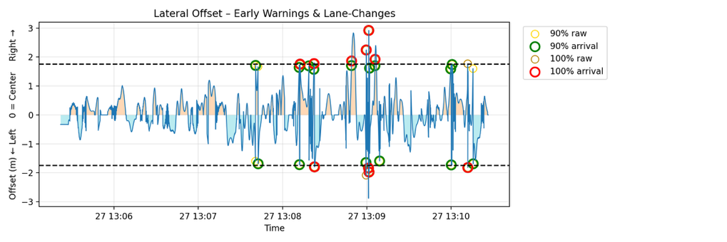
Fig No.5 :- Lateral offset data for Ghulam_KSS_5
For Online integration:- Created Ros Node with the feature extraction node for Carla which will subscribe the data synchronization node and then publish at /features_carla- topic which can be seen in the Fig no. 6(red circled). Which the fatigue estimation node will subscribe to.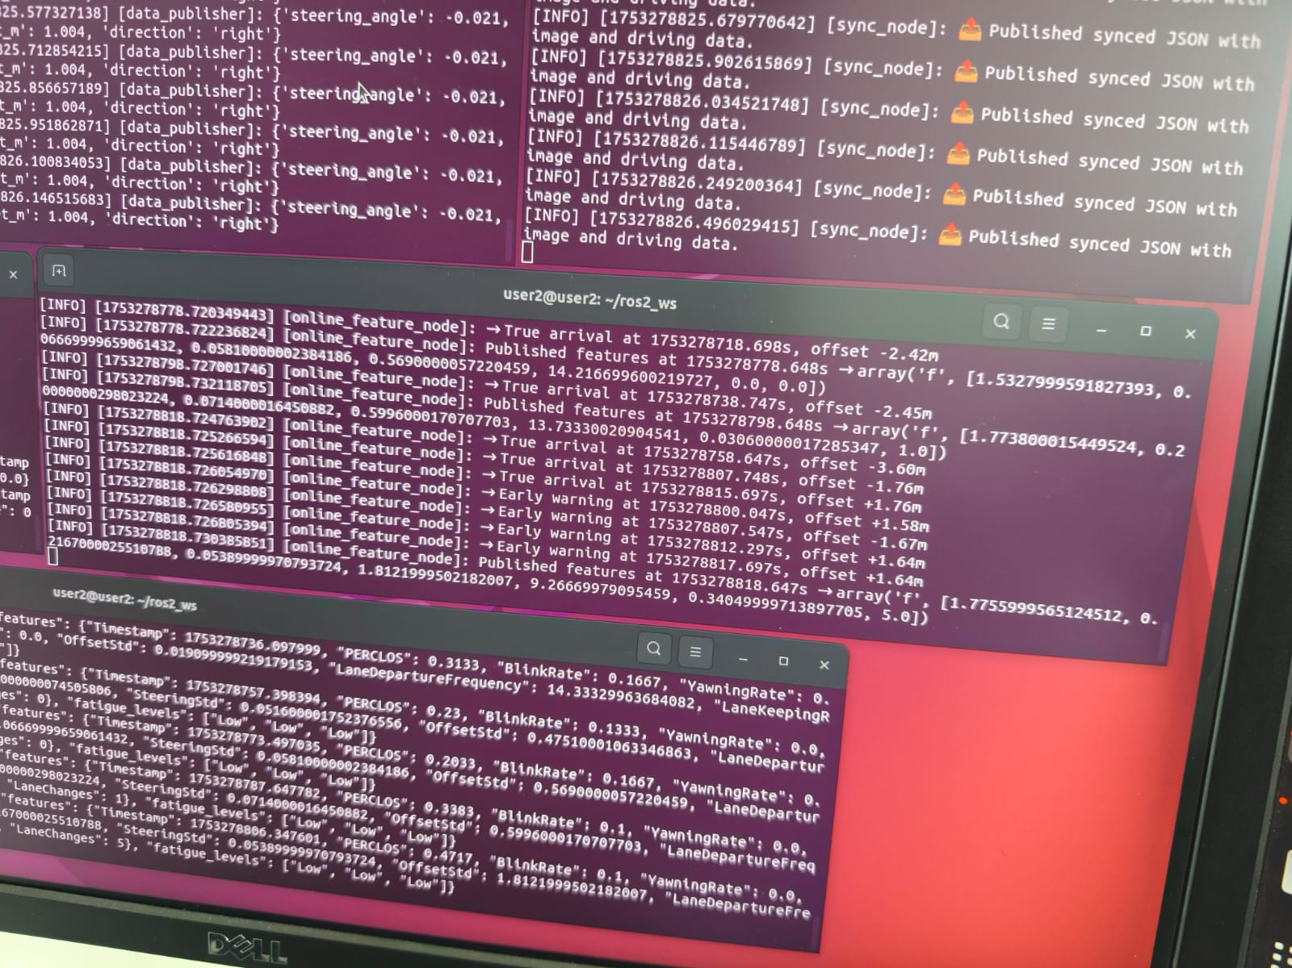
Fig No.6 :- Feature Vector in Online mode with all nodes working.

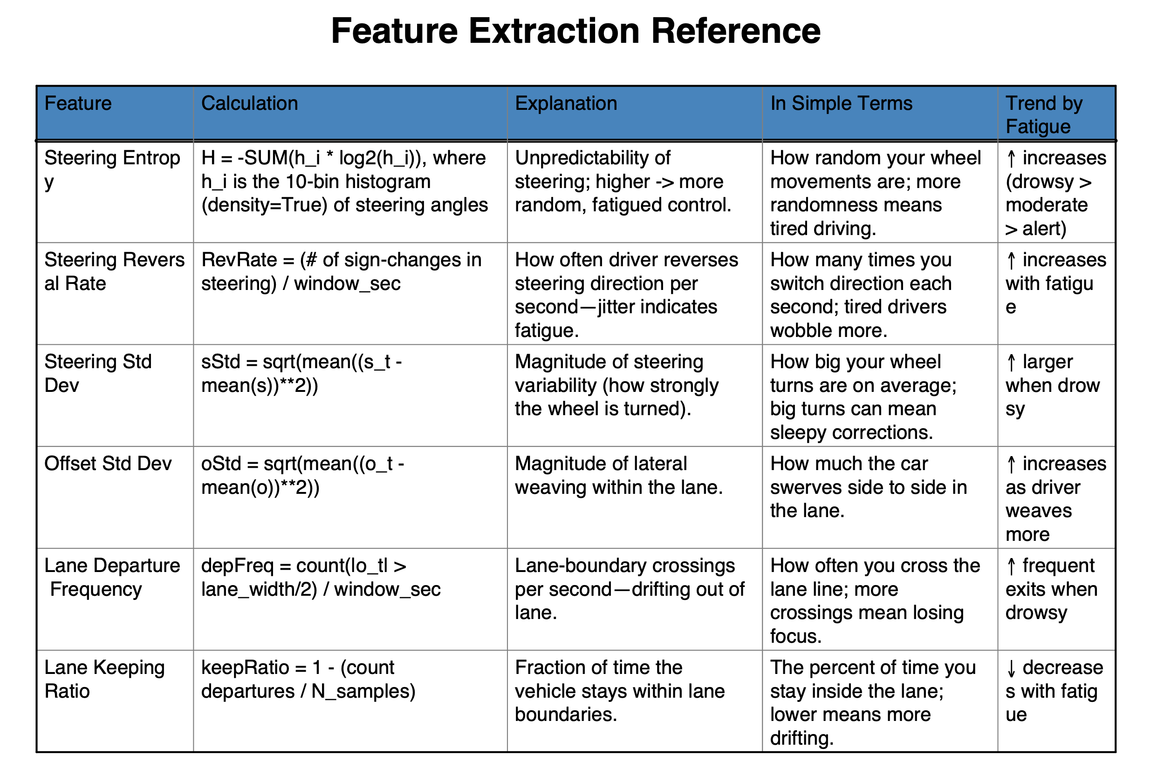
Fig No. 7:- Description of how the features should look and how the trend of fatigue level should be.
5. Reflection & Lessons Learned (~ 250 words / ½ page)
First or all, I would like to thank you Prof. Ignacio Alvarez. For taking an initiative and coming up with this project and allowing me to be part of this project as I was not technically appointed to this project.
- This was my first time working on a large, international team. I coordinated across three sub-teams to ensure our requirements were understood—special thanks to Theresa, who bridged communication with Data Capture.
- During my Bachelor’s Thesis also I had tried CARLA simulator, but at that time the resources were not that good and materials were also not that much, so I wanted to learn how to use and communicate with CARLA Simulator, which I think so I have learned in this project mainly.
- Working with CARLA for the first time deepened my understanding of ROS message formats and latency—skills I’ll carry into future simulator integrations.
- This project cleared many of my concepts of LLM and Deep learning and in general Machine Learning in practical application.
- I attended most (6 out of 8) of the meeting online in the month of may and June due to my internship. All the rest of the time I was there offline in the lecture room or in the simulator setup room.
- We had late night meeting within the feature extraction to brainstorm how to extract features right from the start to the end including tackling the problem of lane change detection from the lateral offset. In this Theresa helped in going physically to the setup and recording the lateral offset data from the CARLA and also video recording the data of her driving the vehicle in the simulator.
- I implemented an early-warning lane-change detector to handle CARLA’s ±2 m jumps in offset data which was possible due to the recording provided of driving.
- Had regularly update the Git for my part of feature extraction on the offline data and also the input signal processing part.
- Co-edited the shared paper on overleaf added feature extraction for CARLA section.
- The main thing about this level of project is communication and delivering the part which you are suppose to do so that the next team which is depended on us does not lag and the not letting the project planning to be sabotage, which I think so I was successful in delivering.

6. Future Work (optional ½ page) (~ 250 words / ½ page)
- Create a joint Github repo in which each team will be given their branch or each person can be given their branch and it should be updated each week so that rest of the team can have a look.
- For internal communication also teams should be used as there were many times when the other team mate will reply late and the deadline might have past and because of him the entire timeline of the project would sacrifice.
- The Deadlines and Project milestones and presentation should be done and completed before the examination period so that we have time to study for our exams.
- We as a team appreciated that there was a rough concept design already present and we had to build on top of that, which saved us very time.
- Project management tools should have been integrated for better understanding of the tool and how it works basically.

7. References (optional)
- This were the papers used to get the reference of how the features might look for vehicle based data. (https://www.researchgate.net/publication/51177546_Standard_Operation_Procedures_for_conducting_the_on-the-pxroad_driving_test_and_measurement_of_the_standard_deviation_of_lateral_position_SDLP)
- I found out one paper in which all the things we are supposed to do we all researched before but not implemented. (https://arxiv.org/pdf/2208.14694)

8. Appendix (Optional, unlimited)
Links to the documents folder
Github repo - https://github.com/haider-maker/Driver-Drowsiness-Detection (commits can be seen on the github)
One drive link for our feature extraction part:- https://thide.sharepoint.com/:o:/r/sites/GR-AImotion-LLMbasedDriverMonitoring/_layouts/15/Doc2.aspx?action=editNew&sourcedoc=%7B3e698c09-8f74-462e-8069-8752bb8fa5ee%7D&web=1
03-CARLA and 04-ROS-data branches were created by me and updated by me for the recorded data and the codes and the issue related to lane change and also have kept documentation in that folder.
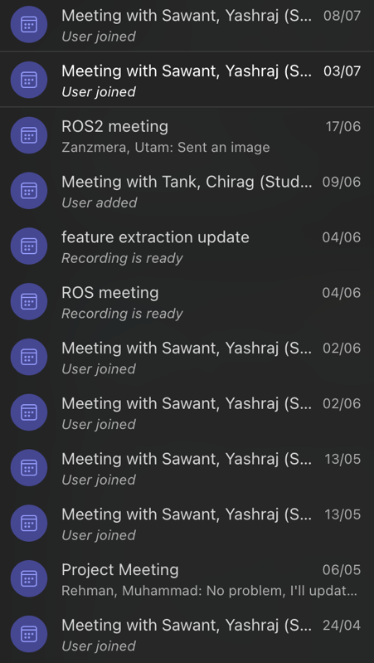
Fig. no. 8:- Team Meeting logs(more logs in the end of the report)

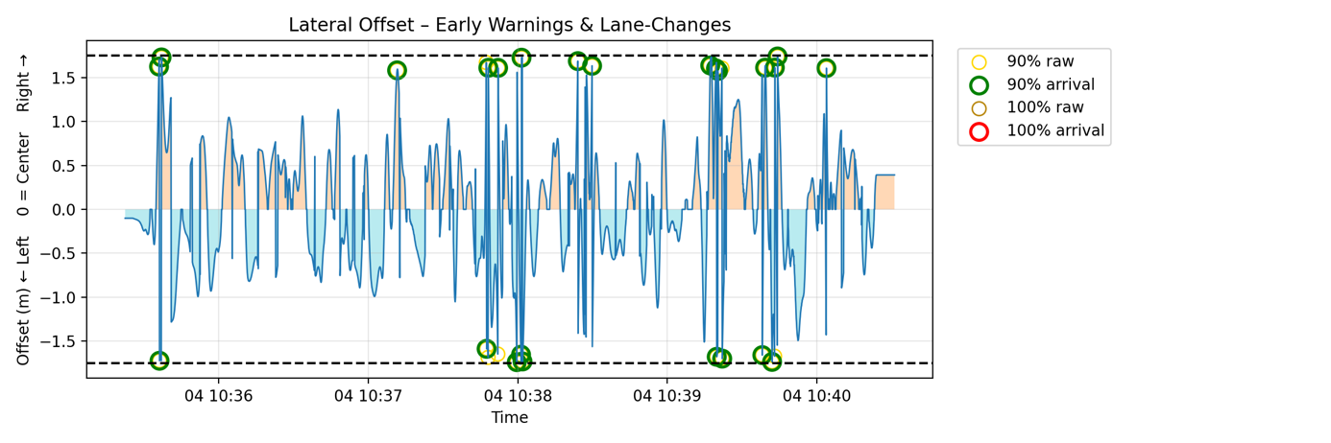
Fig no. 9. Lateral Offset data visualize for Hamza_KSS_2
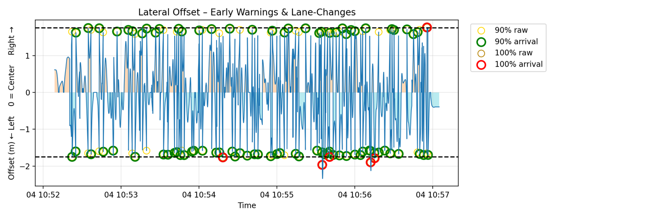
Fig no. 10. Lateral Offset data visualize for Hamza_KSS_5
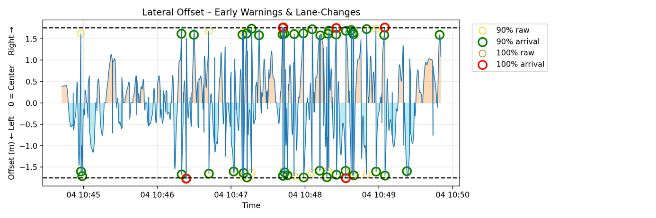
Fig no. 12. Lateral Offset data visualize for Hamza_KSS_9

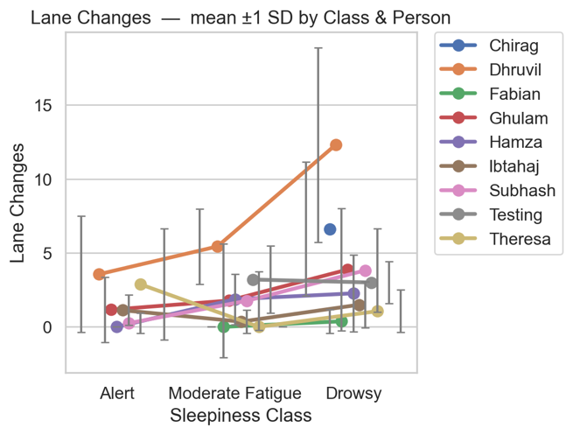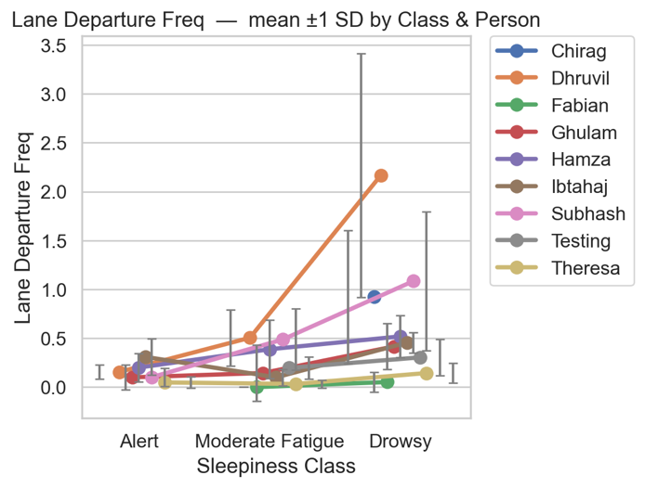
Fig No. 12:- Line plot of Lane change and Lane Departure Frequency according to the class for recorded data.

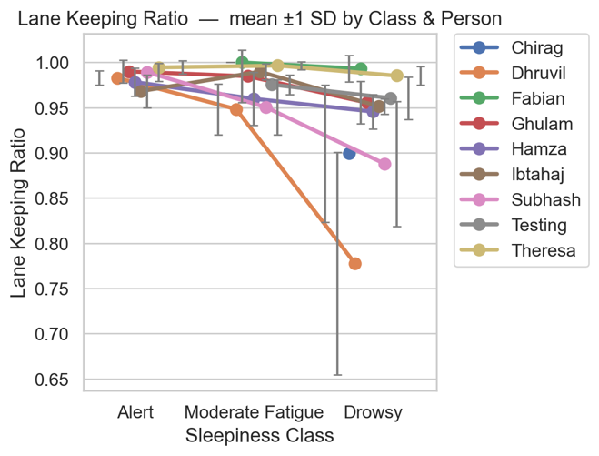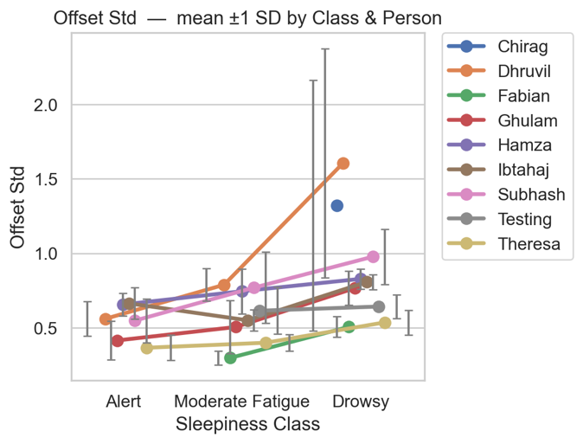
Fig No. 13:- Line plot of Lane Keeping Ratio and Lateral Offset Standard Deviation according to the class for recorded data.

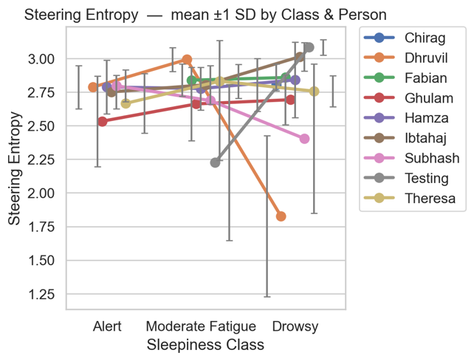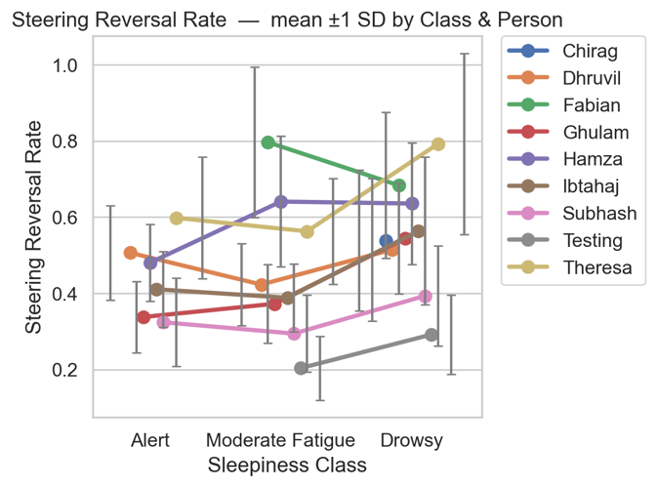
Fig No. 14:- Line plot of Steering Entropy and Steering Reversal Rate according to the class for recorded data.
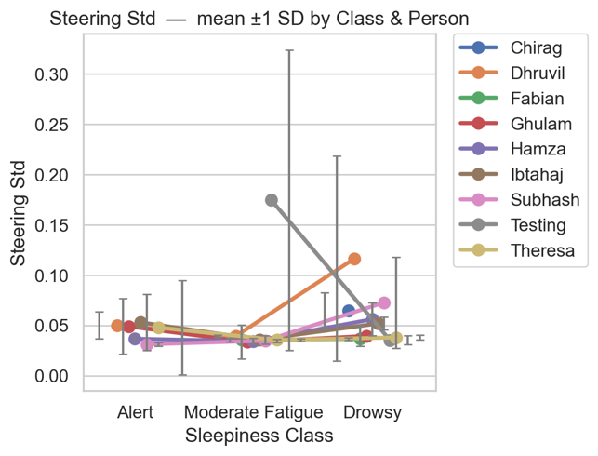
Fig No. 15:- Line plot of Steering Standard Deviation according to the class for recorded data.

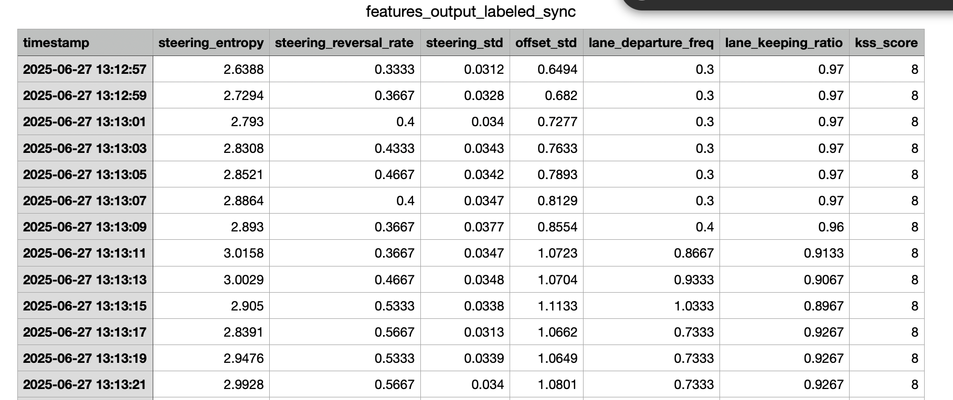
Fig No. 16:- Feature Vector at 10hz for Ghulam_KSS_8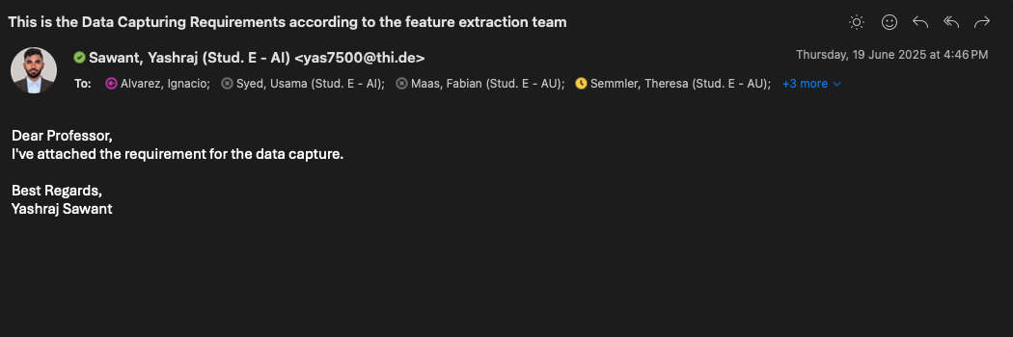
Fig 17:- No acknowledgement from data capturing team about the requirement by feature extraction team

